
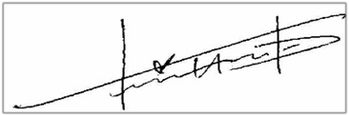

28 November, 2014
Sovex Quotation #
SOV06029
Priyanka Patil
NIHVA Technologies Pvt. Ltd. | Sovex Systems Sdn Bhd  No. 33 Jalan 20 Taman Sri Kluang
G-Block, Sameer Plaza, Thermax Chowk, Chinchwad, Pune, 411019, Maharashtra, India | 86000 Kluang Johor Malaysia Tel: +607 772 8323  Fax: +607 773 9323  www.sovexsystems.com
Tel: +91 2066 3040 33 | Richard Yee
support@nihva.com | Mob: +65 9456 1197
 | richard.yee@sovexsystems.com
Sovex Unit Reference :- | TL2 - 5/7- 600
Dear Priyanka,
Thank you for your enquiry. Please find below our offer for our TL2-5/7-600 Mobile Telescopic Belt Conveyor.
I trust that this will meet with your approval and if you have any queries please do not hesitate to contact me.
Manufacture
Our dedicated and skilled workforce has been responsible for some of the most significant technical developments in the field of conveyor and boom manufacture.
Design
At the heart of every system is equipment designed and engineered to deliver the highest level of reliability and efficiency. We provide a one stop conveyor solution with our customers benefiting from the high quality of products, innovative design features, reduced running costs and minimal maintenance.
Service
We have over 30 years experience in the design manufacture, installation and service of conveyor equipment. The efficient service and maintenance of our customer’s equipment is central to our business.
Yours Sincerely
On and for behalf of Sovex Systems Sdn Bhd
Richard Yee
Business Development Manager

Introduction
Quotation Overview
Scope of supply is to provide 1 unit Mobile Telescopic Belt Conveyor to NIHVA Technologies Pvt. Ltd.
Version Control
Version Release date Changes
Version 1 | 28 November, 2014
Sovex Contact Details
All communications in response to this document should be directed to:
Richard Yee ;- +65 9456 1197
Steve King :- +60 13 7200 426
Steve Nuttall :- +44 796 732 2863
Malcolm Dooley :- +44 774 766 4040
Reference Documents
Quotation Ref :- SOV06029
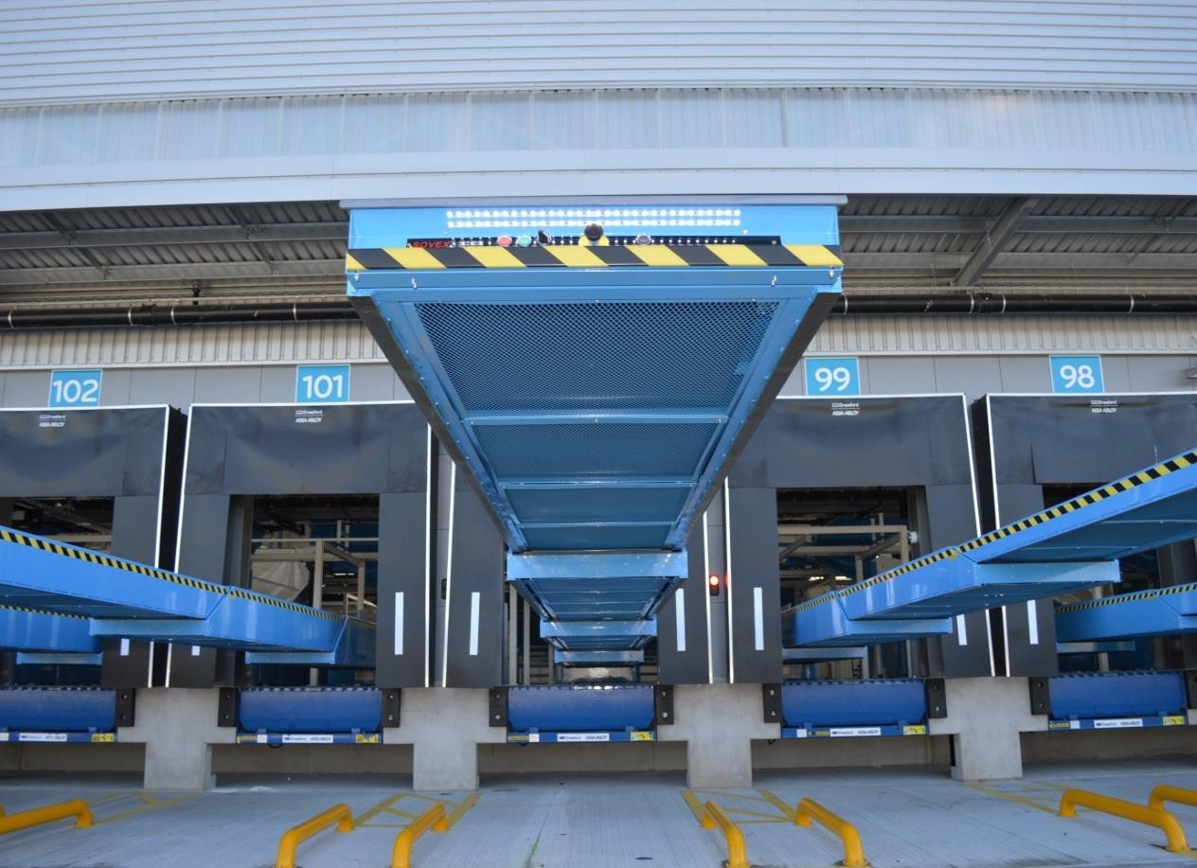

TL2 - 5/7- 600
Overall Dimensions
Overall closed length | 5000mm standard
Total extended length | 12000mm standard
Cantilevered length | 7000mm standard
General Specification
Height to top of belt | 850mm minimum
Belt width | 600mm nom.
Belt type | Smooth face PVC top, 2 ply
Belt joint | Vulcanised joint
Belt drive | Geared motor unit
Telescopic drive | Synchronised positive chain drive
Loading Capacity
Per metre | 50kg/metre
Control & Operation
Main supply | 415v, 3ph rated at 20amps (per conveyor) 50hz
Main supply connection | Isolated supply to be provided by the customer to control panel
Control voltage | 24v dc
Emergency stops | 1-off front boom
Belt speed | 30m/min. Inverter controlled
Belt direction | Reverse (unloading)
Belt controls | Start / stop push-buttons
Extend/Retract speed | 0.25m/sec
Extend control | Push button on front boom
Retract control | Push button on front boom
Up/Down movement | N/a
Traverse movement | Control station and handle
General Information
Type of front boom | Impact plate
Mounting type | Mobile powered chassis
Colour specification | RAL Customer to confirm
Included in Specification
Boom end lights | LED light units mounted in the front boom providing illumination in the vehicle, the lights automatically switch on when boom extends and switch off when the booms are fully  retracted.
Audible warning | Audible warning to alert operator of impending belt starts.
Impact strip | Anti-collision strip fitted at the front of the boom which causes the machine to retract should it encounter an  obstacle at the front of the machine.
Impact plate | 5mm thick impact plate fitted to the front of the machine to take impact from product being dropped onto the machine.
Inverter on belt drive | Progressive acceleration of belt up to running speed and  controlled stop used when the belt will be subject to regular start / stop operation.

Chain sensors | Sensors positioned in main casing to detect if boom drive chains slacken due to a fault. When active, sensors stop the  machine preventing further damage.
Underside covers | Painted sheet steel covers fitted to all telescopic sections to  prevent operators from touching internal moving parts of the machine.
Additional Items
Mobile powered chassis | Heavy duty chassis fitted to machine enabling machine to be moved. This is facilitated by two motors and a control handle. The chassis is fully counterbalanced so no extra support is required. Ideal for traversing between doors and  storing out of the way.
Rear pop-out roller | Interlocked roller fitted to rear. When sensor activated, belt  stops preventing injury. Front pop-out roller is included as standard.
Additional Items to Standard Specification
Mechanical
 | Description | Qty
Low level rear stand top pivot, pair |  | 1
Hydraulic rams+ power pack low level |  | 1
Powered mobile counterbalanced chassis (Tiller type) |  | 1
Electrical
 | Description | Qty
Belt inverter 1.5kw |  | 1
P.E.C. Parcel Counter / index PEC, includes cover |  | 1
Reversible Belt |  | 1
Rear pop out roller, inc sensors |  | 1
Cable Reeling Drum (15m) |  | 1

Pricing Schedule
The following prices are based on the layouts included and our understanding of our scope of supply based on conversations with the customer.
Pricing is based on the current exhange rate of the British Pound Sterling to the relevant currency indicated. Exchange rate fluctuation may have to be taken into account prior to any acceptance of a PO and subsequent order confirmation
GBP | 0
TL2 - 5/7- 600 Per Machine | £25,532
Quantity | 1
Total for all Machines Ex-Works Malaysia | £25,532
Transportation | Ex-Works Malaysia
Installation / Supervision | NA
Total Cost | £25,532
All prices exclude any local tax or import duties that may be imposed
Lead time ex-works delivery | 16 weeks from date of receipt of PO and delivery of order confirmation
Warranty
The standard warranty period is effective from the hand-over date on all new equipment , or when the system is first used for financial gain, until a period of ONE year or 2,080 operational hours dependent upon which condition elapses first.
Sovex will replace free of any charges, any new component that has failed within this period, excluding belts provided that:
- The system has been maintained and serviced according to the schedules within the manual
- The component has failed through normal use
- The service and maintenance regime has adhered to the recommended system cycles
- The servicing is fully documented and available for inspection by Sovex
- Failure to meet with the above conditions will invalidate the warranty
Rectification of warranty problems will normally be undertaken during normal working hours i.e. Monday to Friday 9.00 a.m. to 5.00 p.m. Attendance out of these hours is by arrangement and may incur overtime charges.
A system cycle is described as a complete service on every area of the system
Number of average weekly  operational hours | Recommended system cycles
Forty | Every four months
Sixty | Every three months
Eighty | Every two months
Greater than Eighty | By arrangement

Payment Terms
Your enquiry date: | Via mail dated the 28th November 2014
Sovex Systems Representatives: | Commercial: Richard Yee
Sovex Systems Representatives: | Technical: Martin Henderson
Product description: | Mobile Telescopic Belt Conveyor
Delivery date: | 16 weeks from date of receipt of PO and delivery of order confirmation
Delivery Address: | Ex-Works Malaysia
Terms of delivery: | Supply Ex-Works Malaysia
Projects under £10,000 value: | 100% Upon delivery.Payable 30 days
Projects over £10,000 value: | 35% Deposit with order. Payable 7 days
 | 65% Of total order value upon delivery of equipment to site. Payable 30 days
 | 5% On signed hand-over certificate (if the hand-over certificate has not been signed and returned to Sovex or a written objection has been raised 1 week after the receipt of the hand-over certificate, Sovex systems considers the order delivered and approved. Therefore, the last instalment falls due).
Validity: | 30 Days from date of offer.
Equipment Availability
Availability of equipment depends on the availability of raw materials and bought out items at the time the order is placed. A dedicated Project Manager will prepare a detailed programme for the works.
Spares
A comprehensive list of recommended spares can be submitted upon order placement.
Servicing / Sovex Service Connect
SOVEX have a range of service proposals that may be offered for the support of the system. Should this facility be required then a proposal matched to the particular needs of the customer will be
prepared
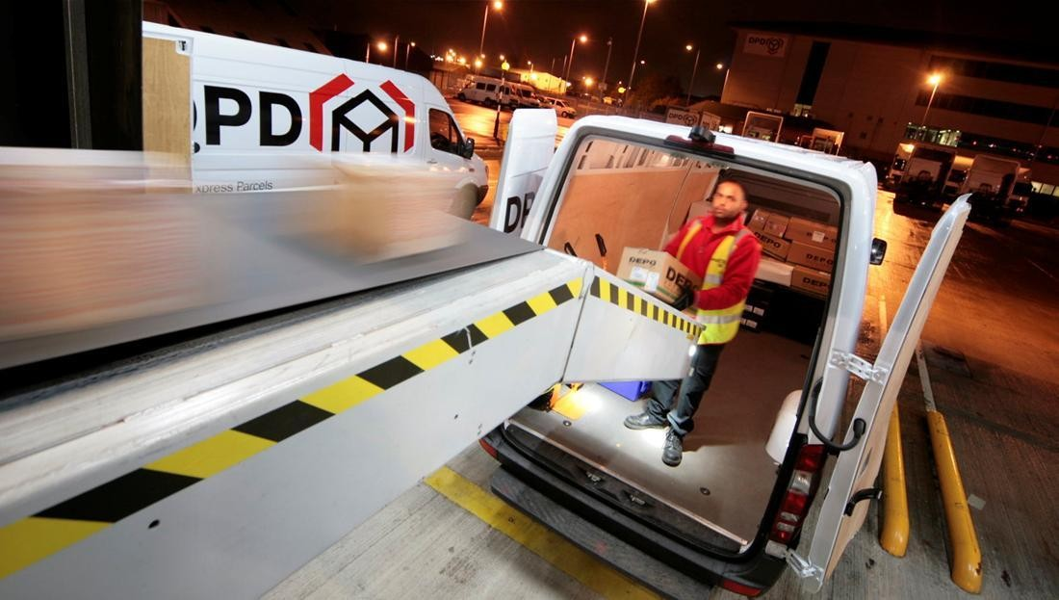


Product Details
Physical load dimensions
Max
Length | 600mm
Width | 300mm
Height | 400mm
Weight | 40kg
Min
Length | TBA
Width | TBA
Height | TBA
Weight | TBA
Items to be Conveyed
Plastic Bags
Paper envelopes
Jiffy envelopes
Rigid cartons
Shoe type boxes
Textile bags
Board boxes
Cartons
Shrink Wrap
Banded board boxes
Heat sealed shrink wrap
System Operating Parameters
For the purpose of this proposal it is assumed that the system is in use 8 hrs per day, 40 hrs per week, 52 weeks per year.
Environmental conditions are dry, with no adverse fluctuations in temperature or humidity generally between 0 and +35 deg C.

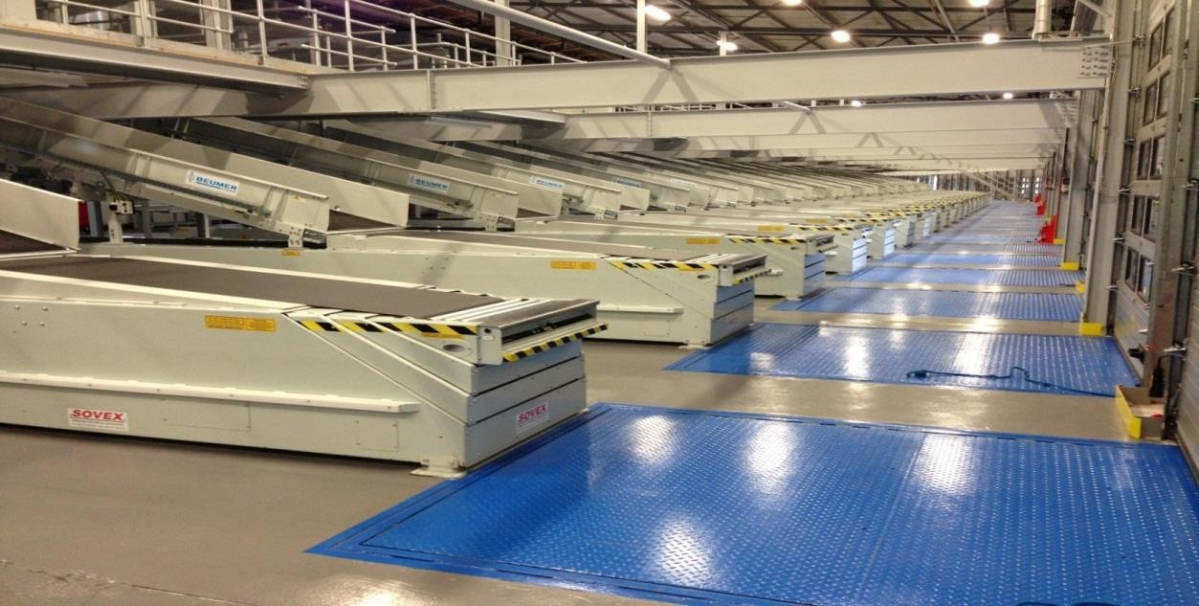

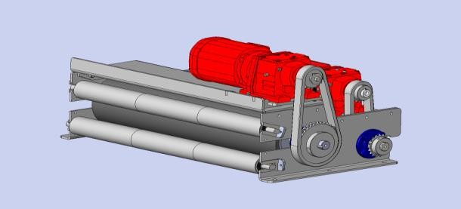
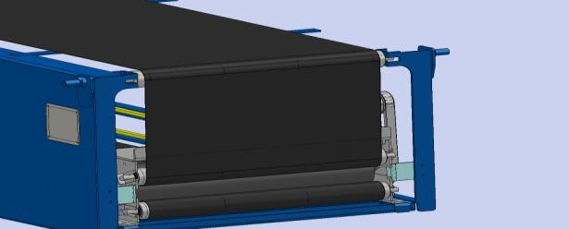
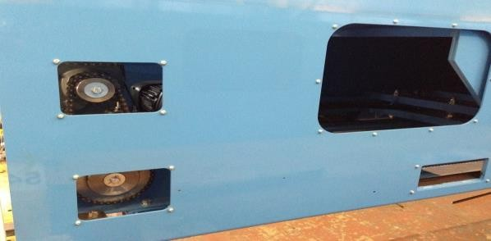
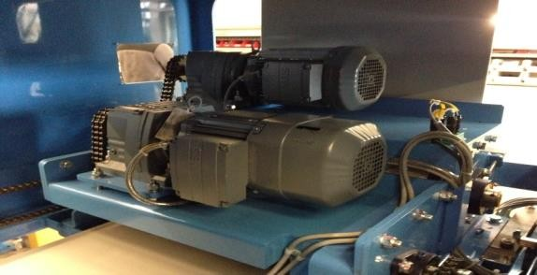
Technical specifications of our equipment
Cost efficiencies
Sovex is always looking for ways to increase efficiencies for our clients. Sovex conveyers are designed to be cost efficient. Therefore our philosophy has always been:
“Making life easier for the operator whilst giving the customer the potential to save money”
Below we outline some of the features of our machines that make them more cost efficient.
Sovex belt drive system
The belt drive system of Sovex is energy and therefore cost efficient for the following reasons:
- Drive drum is lagged with a 15mm thick diamond pattern rubber coating
- Belt is driven on the top surface of belt to give maximum drive efficiency as opposed to driving on the underside which has a low coefficient of friction. This means that we do not require as much tension on the belt which in turn reduces the amount of power required from the motor to drive the belt. Please see sketch below:
Reduced cost of ownership
Furthermore all drive parts are easily accessible through side and rear covers so for service purposes there is easy access.
Because of this easy accessibility the maintenance per year can be reduced significantly. Also the repairs that are needed can be done easier and quicker.
Motors used in the conveyors
SEW Efficient motors are a standard component in the SOVEX vehicle loaders. Sovex uses SEW motors as SEW is taking the lead in the race to reduce carbon emissions by supplying IE2 motors as its standard solution now, 9 months in advance of the new EuP legislation. As a global leader in Drive Technology SEW takes its contribution to environmental issues very seriously.

LED Lights
63mm long Side LED light 285 Lumin at 1m
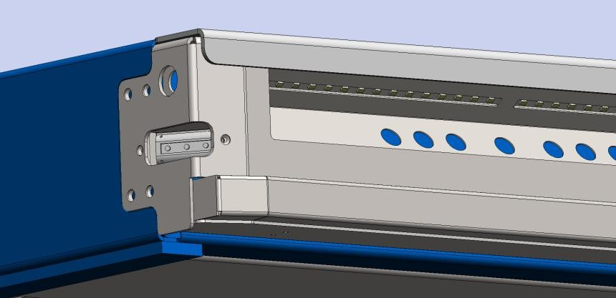LED lights are an energy efficient way of illuminating the workspace inside vehicles. Sovex is constantly developing new ways of improving the lighting for the operators as we highly regard their working environment. Please find below drawings of an improved way of lighting the working environment inside vehicles: LED lights are positioned in various places to ensure maximum light output is achieved, which do not dazzle the operators. 600mm long strip LED lights are fitted in the front and down the side of the front boom, the light emits a fan shaped light
600mm long Front LED light 460 Lumin (162 lux) at 1m

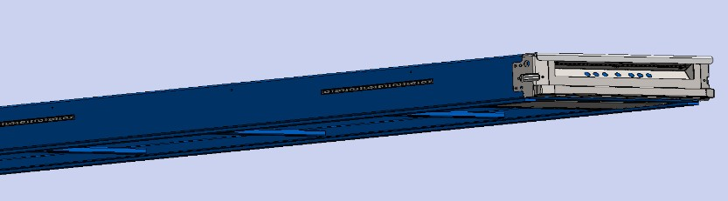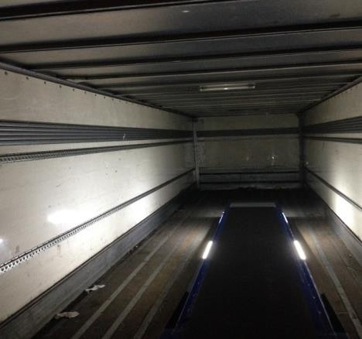

2 x 600mm long Front LED lights fitted both side of front boom each emitting 460 Lumin (162 lux) at 1m

Sovex display (OPTION)
Therefore we have designed a display that is cost efficient as it saves cost for engineers.
Two line text display which gives operators valuable information relating to a machine problem which could potentially save a service engineer visit.
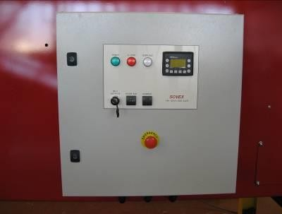
Displayed are the following: Emergency stop pressed Motor overload tripped Pop out roller ejected Slack chain detected Machine service due

Motors used in the conveyors

Safety & Ergonomic features
Front boom section
Sovex conveyors have front end sections that are very safe and ergonomically designed. They are
mounted standard with the following:
Deep section to cope with the daily arduous task of impact loading
Push buttons ergonomically positioned at 45 degrees to allow the operator to clearly see which
button is being pressed
Pop-out roller is electrically switched on outfeed application for added safety for the operator
All push buttons are protected by a 5mm thick steel cover plate
Nautilus side lights to give improved visibility in the back of the trailer for the operator light
automatically come on when boom extends and switch off when booms are fully retracted
Wampfler anti collision strip protected by robust steel cover
Programme and Installation
General
This proposal does not include include for mechanical and electrical installation of the equipment
listed above. However, if this is required, the below conditions would apply:
Our standard working week comprises 10-hour days of unlimited access to site.
The normal working hours are 7.00 am to 7.00 pm subject to minor fluctuation to suit the customer.
Installation is executed to ISO 9001 procedures, with particular reference to CDM, health and safety,
Site teams will expect the use of sanitation and medical facilities while on site.
Programme
A full program of works will be submitted upon order placement
Installation
The mechanical installation is assumed to be conducted during normal working hours for all work. The installation will be carried out in zones, as agreed with the site manager and the customer to minimize
operational disruption.
Should there be a requirement by SOVEX or the customer to extend the working week to 7 days per week then the customer should make the premises available for this time.
Installation Conditions
SOVEX will make all working areas safe by using hand railing, meshing and temporary fencing to
prevent equipment from falling if required.
An agreed area of internal storage space will be provided for use by SOVEX as a storage, marshalling
and temporary working area.
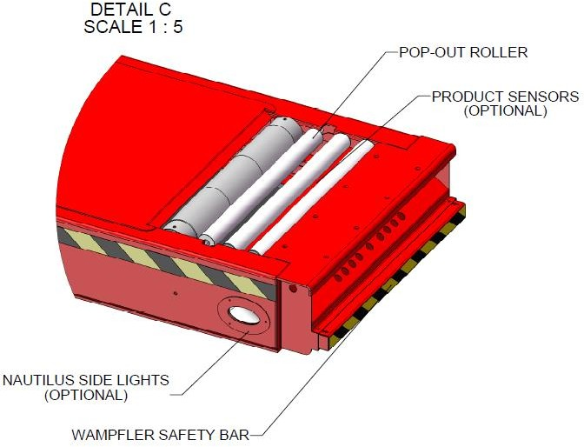

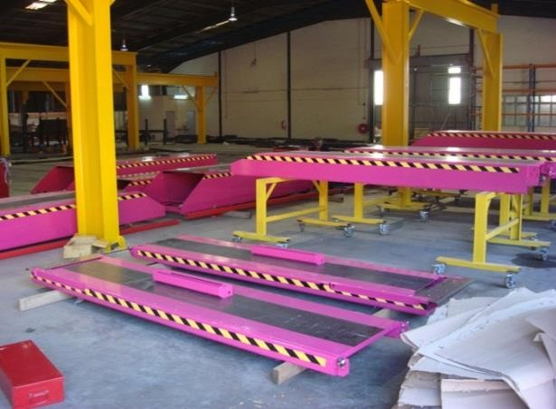
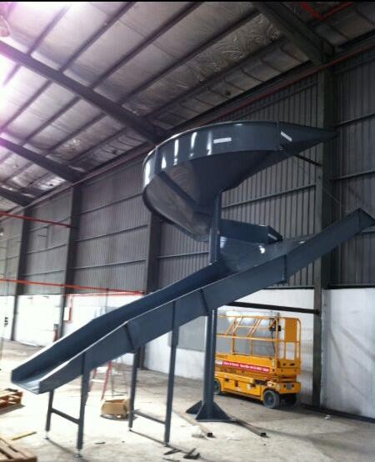
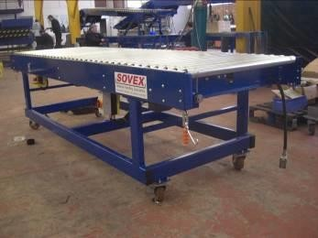

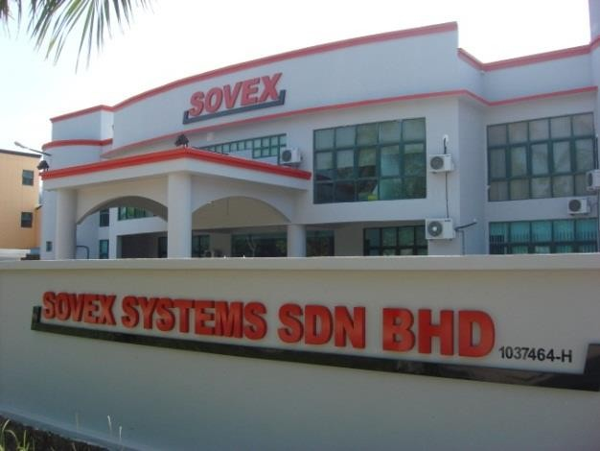
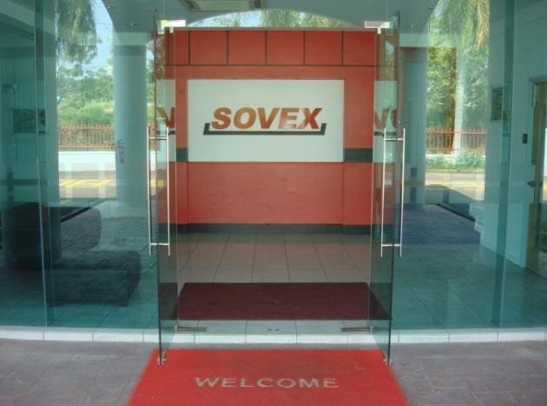
Sovex Malaysia

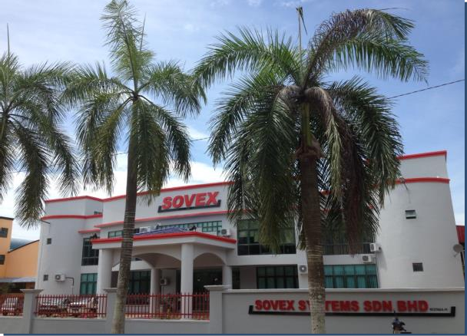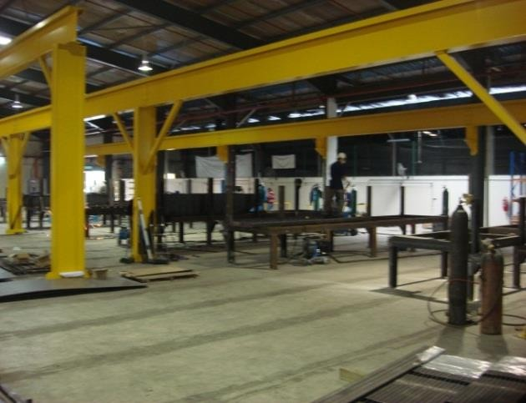

GENERAL TERMS AND CONDITIONS
1. General
These terms apply to and are incorporated in each and every Order accepted or Contract for the supply of Goods and/or materials and/or services (hereinafter called ‘Goods’) by SOVEX Ltd (hereinafter called ‘the Company’).
There shall not be any variation or alteration or modification or waiver of all or any of these terms unless set out in writing and signed by a person duly authorised by the Company.
Where the Customer submits to the Company the Customer’s own form of Order with the Customer’s terms and conditions of Order, such terms and conditions are not accepted by the Company and are not incorporated in the Contract for the supply of Goods by the Company.
2. Acceptance
Orders and contracts are only accepted on these terms and conditions, irrespective of any terms or conditions printed on Customer order forms unless previously agreed and accepted writing by the Company.
3. Contract Price
Prices quoted by the Company are based on current costs/manufacturers prices are subject to increase at any time between the date of the order and the date of the Company’s acceptance. All prices are subject to confirmation by the Company at the time the order is accepted. All prices are exclusive of VAT and VAT shall be paid thereon.
4. Pacjing and Carriage Charges
These are additional to the Contract price and will be charged to and will be paid by the Customer cost unless otherwise stated.
5. Payment
Terms of payment are 35% with order payable 7 days, 60% upon delivery 5% from handover payable 30 days for projects over the value of £10,000. Payment terms for projects under this value are 100% from hand over payable 30days. Should payment not be made as and when it becomes due, the Customer shall pay interest at the rate of 8% per annum on the sum due from the date of
the Companies invoice.

GENERAL TERMS AND CONDITIONS ( Continued )
6. Retention of Title
a) The property in the Goods remains vested in the Company and shall not pass to the Customer until the Customer shall have made payment in full of all sums due to the Company under any contract between the Company and the Customer.
b) Sub-Clause a) above shall not be affected by any alteration or addition of the Goods.
c) Until the property in the Goods shall have passed to the Customer the Company shall be at liberty at any time to re-take possession thereof and for that purpose to enter upon the premises of the Customer.
d) The Customer shall not resell or otherwise dispose of or mix with other Goods or otherwise loose the identity of the Goods prior to payment being made pursuant to sub-clause
a) and prior to the passing of the property therein to the Customer. If in breach of this condition the Customer purport to sell or otherwise dispose of the Goods the Customer shall hold the proceeds of any such purported sale or disposition on trust for the Company. This shall be without prejudice to any other rights and remedies vested in the Company as a result of such breach.
e) Not withstanding the foregoing, the Goods shall be at the risk of the Customer from the
time of delivery to the Customer’s premises or other premises nominated by the Customer and shall be stored by the Customer in a proper and suitable manner so that no damage shall be caused to the Goods.
f) Until such time as the property in the Goods has passed to the Customer, the Customer shall keep the Goods separate and apart from other items of similar natures that they may be easily identifiable in the event of the Company requiring to re-take possession.
g) Until such time as in the property in the Goods has passed to the Customer, the Customer irrevocably authorises the Company, it’s servants, and agents to enter upon the premises where the Goods are stored and to re-take possession of them in the event of:
i) the levying of any distress or execution upon any of the assets of the Customer or
ii) the commencement of legal proceedings against the Customer for the purpose of liquidation or winding up or bankruptcy or
iii) the appointment of a Receiver over the whole or any part of the Customer’s undertaking
iv) the calling of a meeting of the Creditors of the Customer.

GENERAL TERMS AND CONDITIONS ( Continued )
7. Lien of Goods
In addition of any right of lien to which the Company may by law be entitled to the Company shall be entitled to a general lien on all Goods of the Customer in the Company’s possession (although such Goods or some of them may have been paid for) the unpaid price of any other Goods sold and delivered to the Customer by the Company under the same or any other contract.
8. Loss or Damage in Transit
The Customer shall examine the Goods immediately upon delivery at the Customer’s premises or other premises nominated by the Customer. Any shortage of Goods and/or damage to Goods prior to or during the course of delivery must be notified to the Company in writing either by endorsement on the delivery sheet or otherwise within 14 days of receipt by the Customer, failing which no claim will be accepted by the Company and he Company is hereby discharged from any claim and/or liability in respect of such shortage and/or damage which is not reported as aforesaid.
9. Warranty
a) For the period of 12 months from the date of dispatch, the Company will replace any parts manufactured by the Company where the parts are used for the purpose notified to the Company prior to the Contract being entered into and which are proved to be defective solely as a result of fault on the part of the Company. The costs of delivery and installing replacement parts shall be agreed between the parties and failing agreement shall be borne by the Customer.
b) In the case of Goods (including parts) not manufactured by the Company, the manufacturer’s warranty and/or guarantee (if any) in respect of the whole or any part of the Goods is not incorporated as an express or implied term of the contract and any manufacture’s warranty and/or guarantee does not constitute a representation on the part of the Company in respect of the whole or any part of the Goods and the Company has not approved adopted or made any representation
pursuant to any manufacturer’s warranty and/or guarantee in respect of the whole or any part of the Goods; if and in so far as the same is assignable, the Company hereby assigns to the Customer the benefit (subject to burden) of any manufacturer’s warranty and/or guarantee in respect of the whole or any part of Goods; the Customer is entitled to the benefit the Company receives of any warranty and/or guarantee given to the Company by the manufacturer in respect of the Goods; the Customer has and shall have no warranty claim or remedy howsoever arriving against the Company in respect of any defects in the Goods; the Customer acknowledges that any warranty and/or guarantee claim which the Customer has or may have in respect of the whole or any part of the Goods lies against
the manufacturer of such Goods on the terms of the Manufacturer’s warranty (if any).
c) This clause expresses the full extent of the Company’s warranty in respect of the Goods.

GENERAL TERMS AND CONDITIONS ( Continued )
10. Indemnity
The Company’s quotation is based on the details given to the Company by or on behalf of the Customer and the Company relies on all such representations and all such representations from the basis of any resultant contract. Any variation of such details without the agreement of the Company may invalidate the warranty provided by clause 9.
11. Delivery
a) The Company will endeavour to comply with any date given by the Company for dispatch or delivery or supply of the Goods but such date is given and intended as an estimate only and time shall not be of the essence of the contract on this regard.
b) If owing to the non-availability to the Company of Goods (including parts) or services or to any other cause beyond the control of the Company it proves impossible or impracticable to effect delivery of the Goods to the Customer the Company shall be at liberty to determine the contract or part thereof by giving notice in writing to the Customer.
c) The Company shall not be liable for any loss or damage arising directly or indirectly from any delay and/or failure to dispatch and/or deliver the Goods.
d) If:
i. The customer fails and/or refuses to accept delivery of the Goods for any reason whatsoever or
ii. Goods are returned to the Company for any reason whatsoever or
iii. The Customer wrongly releases the Goods to a third party
The Customer shall pay the Company the costs of and incidental to the delivery andiInstallation and removal and recovery of the Goods and this shall be in addition to and without prejudice to any other right or remedy of the Company.
12. Loss and damage
a) The Company’s liability to the Customer for any misrepresentation and/or breach of contract and/or negligence shall in no case exceed the Contract price, and save as aforesaid the Company shall in no circumstances whatsoever be liable to the Customer in respect of any loss or damage whether direct, indirect consequential or howsoever else arising.
b) Provided always that sub-clause a) shall not restrict the Company’s Liability for death or personal injury arising from any negligence on the part of the Company.
13. Law
The Contract is and shall be deemed to have been made in Prenton and shall in respects be governed by English Law and the parties submit to the exclusive jurisdiction of the Birkenhead District
Registry of the High court of Justice and Birkenhead County Court.

